function varargout = SoilAnalyzer(varargin)
% SOILANALYZER MATLAB code for SoilAnalyzer.fig
% SOILANALYZER, by itself, creates a new SOILANALYZER or raises the existing
% singleton*.
%
% H = SOILANALYZER returns the handle to a new SOILANALYZER or the handle to
% the existing singleton*.
%
% SOILANALYZER('CALLBACK',hObject,eventData,handles,...) calls the local
% function named CALLBACK in SOILANALYZER.M with the given input arguments.
%
% SOILANALYZER('Property','Value',...) creates a new SOILANALYZER or raises the
% existing singleton*. Starting from the left, property value pairs are
% applied to the GUI before SoilAnalyzer_OpeningFcn gets called. An
% unrecognized property name or invalid value makes property application
% stop. All inputs are passed to SoilAnalyzer_OpeningFcn via varargin.
%
% *See GUI Options on GUIDE's Tools menu. Choose "GUI allows only one
% instance to run (singleton)".
%
% See also: GUIDE, GUIDATA, GUIHANDLES
% Edit the above text to modify the response to help SoilAnalyzer
% Last Modified by GUIDE v2.5 15-Oct-2014 21:36:26
% Begin initialization code - DO NOT EDIT
gui_Singleton = 1;
gui_State = struct('gui_Name', mfilename, ...
'gui_Singleton', gui_Singleton, ...
'gui_OpeningFcn', @SoilAnalyzer_OpeningFcn, ...
'gui_OutputFcn', @SoilAnalyzer_OutputFcn, ...
'gui_LayoutFcn', [] , ...
'gui_Callback', []);
if nargin && ischar(varargin{1})
gui_State.gui_Callback = str2func(varargin{1});
end
if nargout
[varargout{1:nargout}] = gui_mainfcn(gui_State, varargin{:});
else
gui_mainfcn(gui_State, varargin{:});
end
% End initialization code - DO NOT EDIT
% --- Executes just before SoilAnalyzer is made visible.
function SoilAnalyzer_OpeningFcn(hObject, eventdata, handles, varargin)
% This function has no output args, see OutputFcn.
% hObject handle to figure
% eventdata reserved - to be defined in a future version of MATLAB
% handles structure with handles and user data (see GUIDATA)
% varargin command line arguments to SoilAnalyzer (see VARARGIN)
% Choose default command line output for SoilAnalyzer
handles.output = hObject;
% Init Beaglebone connection
global bbb;
bbb = beaglebone_black('192.168.178.20', 'root', 'open');
system(bbb, './pwm_vision_matlab');
% Init the CAM
border = 0;
global cam src;
cam = videoinput('winvideo', 1, 'MJPG_2048x1536');
cam.FramesPerTrigger = 1;
hImage = image(zeros(1536, 2048, 3), 'Parent', handles.axes_Image);
preview(cam, hImage);
cam.ROIPosition = [ border border 2048-border 1536-border ];
%cam.PowerLineFrequency = 50;
% Update handles structure
guidata(hObject, handles);
% UIWAIT makes SoilAnalyzer wait for user response (see UIRESUME)
% uiwait(handles.figure1);
% --- Outputs from this function are returned to the command line.
function varargout = SoilAnalyzer_OutputFcn(hObject, eventdata, handles)
% varargout cell array for returning output args (see VARARGOUT);
% hObject handle to figure
% eventdata reserved - to be defined in a future version of MATLAB
% handles structure with handles and user data (see GUIDATA)
% Get default command line output from handles structure
varargout{1} = handles.output;
% --- Executes on button press in pushbuttonSnap.
function pushbuttonSnap_Callback(hObject, eventdata, handles)
% hObject handle to pushbuttonSnap (see GCBO)
% eventdata reserved - to be defined in a future version of MATLAB
% handles structure with handles and user data (see GUIDATA)
global bbb cam I L Dis labI;
system(bbb, 'echo 1 > /sys/class/gpio/gpio51/value && echo 1 > /sys/class/gpio/gpio50/value && echo 1 > /sys/class/gpio/gpio60/value');
start(cam)
I = getdata(cam);
system(bbb, 'echo 0 > /sys/class/gpio/gpio51/value && echo 0 > /sys/class/gpio/gpio50/value && echo 0 > /sys/class/gpio/gpio60/value');
L = GetLabeledImage(I);
[Dis labI] = CIELabSoilColorDistribution(L, I);
axes(handles.axes_Image);
aImage = I;
image(aImage);
% Update handles structure
guidata(hObject, handles);
% --- Executes on button press in pushbuttonAS.
function pushbuttonAS_Callback(hObject, eventdata, handles)
% hObject handle to pushbuttonAS (see GCBO)
% eventdata reserved - to be defined in a future version of MATLAB
% handles structure with handles and user data (see GUIDATA)
global L dis I P;
% Get CIElab scatterplot
L = GetLabeledImage(I);
dis = CIELabSoilColorDistribution(L,I);
axes(handles.axes_CIE);
ma = mean(dis(:,1));
mb = mean(dis(:,2));
handels.axes_CIE = scatter(dis(:,1),dis(:,2),'.');
hold on
plot([ma, ma],ylim,'r--','LineWidth',1);
plot(xlim, [mb, mb],'r--','LineWidth',1);
hold off
% Get RI Histogram
RI = RISoilColorDistribution(L, I);
axes(handles.axes_RI);
mri = mean(RI);
handels.axes_RI = hist(RI);
hold on
plot([mri, mri],ylim,'r--','LineWidth',1);
hold off
% Get PSD CDF plot
P = PSD(L);
axes(handles.axes_PSD);
handels.axes_PSD = cdfplot(P);
% Get the textuur histogram
% --- Executes on button press in pushbutton3.
function pushbutton3_Callback(hObject, eventdata, handles)
% hObject handle to pushbutton3 (see GCBO)
% eventdata reserved - to be defined in a future version of MATLAB
% handles structure with handles and user data (see GUIDATA)
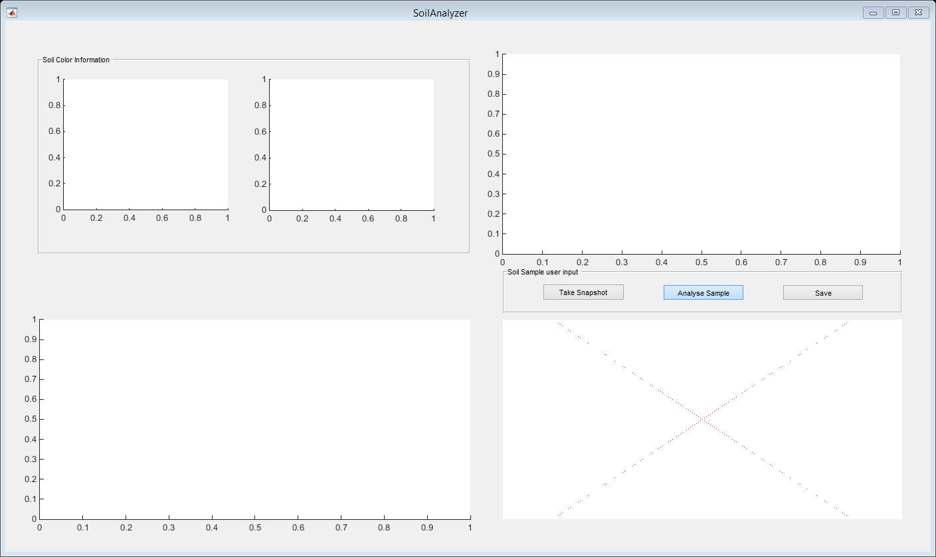
Published with MATLAB® R2014b

